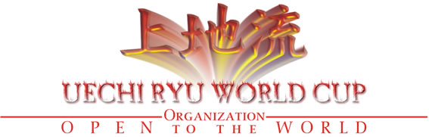
Miami 2014 USA
Address 720 NW 86th AVE. 330024 Pembroke – Pines, Miami, FL USA
USA Organizer Contact Tel. 786-357-9198
Mail: uechiryuworldcup@yahoo.com.ar / Web Site: www.uechiryuworldcup.org

To All Uechi Ryu & Shohei Ryu Karate Do Practitioners and Masters

Dear Uechi Ryu & Shohei Ryu Sensei
Around the World

Present

Dear Sensei,
Through this letter, I have the pleasure to invite you and through you to all instructors and students to participate in the Championships called:

"5th Uechi Ryu World Cup for Peace"
The last World Cup was in 2012 in Argentina with 12 countries participating, now the 5th World Cup will be in Miami Florida United States from Junes 9th until June 16th organized by Sensei Gustavo Gondra & hosted by Sensei Facundo Gallero 5* Degree Black Belt Uechi Ryu Karate Do, the 6 World Cup will be in Cali city Colombia, hosted by Sensei Jorge Chamorro Molineros 6 Degree Black Belt Uechi Ryu Karate Do.

This event will be open to all Schools of Traditional Uechi Ryu Karate-Do, Shohei Ryu, Okinawan and Japanese lines. The overall organization of the Championship is in charge of Uechi Ryu World Cup Organization.

We will use Traditional Shobu-San-Bon for Adults Male and Traditional Shobu-Nihon for Children’s and Female, the Rules regulations will be complete at the Web Site: www.uechiryuworldcup.org

We especially invited to give seminars at the World Cup, Kancho Takemasa Gosei Okuyama 9 * Degree Black Belt Traditional Karate, President of Hachi-O- Kai World Budo Federation, Darin Yee 8* Degree Black Belt Member of IUKF International Uechi Ryu Karate Federation, Sensei Ric Potrekus 8* Degree Black Belt Member of Ryukokaku Karate Do & Kobudo Association and Hanshi Gustavo Gondra 9* Degree Black Belt Uechi Ryu Member of Ryukokaku Karate Do & Kobudo Association en President of WUKKO World Uechi Ryu Karate Do & Kobudo Organization.

Uechi Ryu World Cup Organization is an organization that promotes the Union of Uechi Ryu style around the World through a global event held every two years. Participation is free and open under the International Regulations that owns the entity.

All lines are welcome to join this movement without any political matters.

Hoping to have you here to create strong spirit and energy

Sincerely,
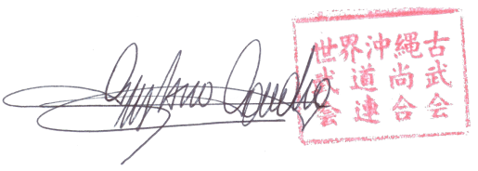
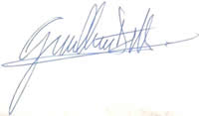

Gustavo Gondra
9* Dan Hanshi – Shihan Master Instructor Facundo Gallero
President Uechi Ryu World Cup Organization Member & Organizer

What is Uechi Ryu World Cup and what is the proposal..!

This is what we propose to all of you once again in 2014, Friendship, Exchange, Brotherhood, Union, Respect others, Loyalty to our Karate Style, Honoring those who are no longer with us in body and soul. Just that, can you do it with us..! We wait for all of you...!
Honor, Loyalty, Justice, Compassion, Honesty, Courtesy, Courage, they are the 7 Samurai precepts, this is Bushido, Karate is a Samurai Legacy and this should be shared and cultivate in each practice, something that many people are forgetting ... If you practice these concepts within you, You are a Karateka ... Uechi Ryu World Cup Organization remind everybody this, if this is forgotten, the practice does not make sense... 2014 is the time to preserve everything with you...
Argentina, Brazil, Mexico, France, USA, Venezuela, Uruguay, Switzerland, Colombia and Italy have confirmed their participation at the 5th Uechi Ryu World Cup for Peace in Miami, June 2014. Are you going to miss it..? Be with us for the most important event of Uechi Ryu Karate Do outside of Okinawa. Be a part of the History of our Karate Style. Be there to create Strong Energy, and a good, pure Spirit. Karate means Empty Hand, “empty" of Evil and Envy. "Do" means "Way", the way of what is right, the way of Honor, the way of Truth, the way of Honesty, the way of Spirituality, respect others, help, energy, humble, these are the principals of the Uechi Ryu World Cup Organization, this is Karate-Do..! These are the concepts that have been lost and we must recover and protect. Together we can do it if we believe in truth and honor. Together we must protect the Karate-Do, a Samurai Legacy. Everyone is welcome to participate and be "ONE more" that will do something about it..! Everybody is welcome and free to participate without any pressure, and be Free. When Sensei Kanei Uechi was alive, he gave us Uechi Ryu karate Do as our Father, meaning we are all Brothers, and Bothers don’t have to fight, they defend the rest of the family. Please, be free to choose to protect our Karate Style, be with all of us at the World Cup, together as family, as Brothers every two years…!

Institutional Characteristics:
World Karate Championships, Uechi Ryu Style.

Endorsements and Awards:
Titles played in the "World events " are guaranteed and supervised by the following Organizations:

Uechi Ryu World Cup Organization
Ryukokaku Karate & Kobudo Association
Panamerican Karate & Kobudo Organization
IKU International Karate Union

Opening Date and Schedule of the Championship:

DATE | EVENT | ACTIVITIES
Monday, June 9 | Delegation’s arrival | Registration
Tuesday, June 10 | Referee Seminar | 09:00 am to 11:30 am
Tuesday, June 10 | Referee Seminars | 2:30 pm to 5 pm
Wednesday, June 11 | Free Day | Free Day
Thursday, June 12 | Karate Seminars | 9 am to 12 noon time
Thursday, June 12 | Karate Seminars | 2 pm to 3 pm
Friday, June 13 | Karate Seminars | 9 am to 12 Noon Time / 2 pm until 3 pm
Friday, June 13 | Opening Ceremony | 6 pm to 8 pm
Saturday, June 14 | Karate & Kobudo Open World Cup | 9 am to 6 pm
Sunday, June 15 | Uechi Ryu World Cup | 9am until 4pm
Sunday, June 15 | Farewell Banquet | 7:30 pm
Monday, June 16 | Delegation’s Departing

Exclusive Services for the Competitor:
☯ Health Care at the Tournament
☯Changing rooms and toilets for competitors.

Mandatory Protections Required:
♦ Official headgear Japan Karate Federation (JKF), provided by the Organization.
♦ Hands protections Official or approved by the Organization and Inguinal Shields (internal or external), both provided by each competitor (personal).
♦ The use of mouth guard under the respective mask, is optional and is subject to the decision of the official coach of each team.

Packages Hotel Tournament Registration Option for Every Competitor
Services included in the Participation Package / Prices are per Person
Take a look to all the Services you have included in the World Cup Package Registration.
Every Package includes the same services; the difference in the price will be depending on the Room you choose.
- Transfer Airport/Hotel
- 8 Days ‐ 7 Nights Hotel (We offer different Hotel Options)
- Accommodation with breakfast and taxes included
- Participation in the World Cup
- Participation in World Karate Seminar
- Participation in World Referee Seminar (Mandatory for every Black Belt)
- Transfer to Tournament Place
- Participation Certifícate
- Tournament Poster
- Official T‐Shirt
- Official Program
- Personal ID Card
- Firewall Banquet
- Transfer Hotel/Airport

Headquarters World Cup 4 Stars Hotel
River Park Hotel & Suites
Room | Price Per Person | Extra Night
Single Room | U$D 855 | U$D 63
Double Room | U$D 727 | U$D 35
3 People Room with 2 Double Beds | U$D 668 | U$D 25
4 People Room with 2 Double Beds | U$D 640 | U$D 20

Option just for US Citizen Competitors
Packages Registration Option for Competitors in United States
Services included in the Participation Package / Prices are per Person
Competitor in US could choose general option
U$D 260.-
- Participation in the World Cup
- Participation in World Karate Seminar
- Participation in World Referee Seminar (Mandatory to be Judge or Referee)
- Participation Certifícate
- Tournament Poster
- Official Program
- Personal ID
- Firewall Banquet

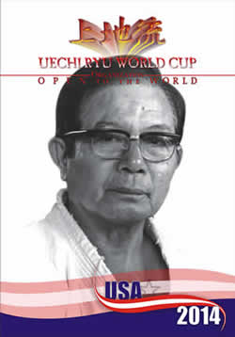
Judges and Referees:
The development of the categories at issue in this championship will be Managed by the Staff of Judges and Referees from Uechi Ryu World Cup Organization, regarding who will be accredited to practice Seminars for leveling will be at the Referees & Judges Seminar mandatory provided for this purpose on Tuesday, June 10th from 09:00 am to 11:30 am and from 2:30 pm to 5 pm .Other organizations will be confirmed at the Seminar which must adapt their knowledge and experiences to the Rules of these regulations.
Awards:
Kumite: Be awarded to competitors who arrive in the First, Second and two Third Place.
Kata: Be awarded to competitors who arrive in the First, Second and Third place.
Registration deadline May 10/2014

The Registrations are open from November 1/2013 until May 10/2014, no extensions of any reason. Competitor is considered registered when have chosen and paid for the package that contains all the services outlined in this invitation and website.

Official Categories

The official categories are published in the Official Website, must complete the form found on the Web Site and e-mail respecting the final registration date.

Web Site:
www.uechiryuworldcup.org

Registration to participate in the 5th Uechi Ryu World Cup Miami 2014:

Notably, in conjunction with the official Registration the owner of each school or each person, must submit an original signed form of "Liability", being endorsed by the specific case of children under 17 years with the signature of Parent or guardian thereof.

Each competitor shall be registered by his Name, plus they were granted an ID Number that must is stuck in the back of each competitor provided by the World Organization for identification to avoid errors.

World Masters Seminar 2014

